Practice for topic 2 – 7– Circular motion
1). [C]
a). Your partner doesn’t remember why $x\left(t\right)=cos(t)$ and $y\left(t\right)=sin(t)$ define a circular motion. Explain why this is true.
b). Would $x\left(t\right)=sin⁡(t)$ and $y\left(t\right)=cos⁡(t)$ define a circular motion? Is it different from the pair of equations in part a? how?

2). [P] Write the equation for circular motion around a circle radius 3, centered on (-4, 5).

3). [C] The purpose of this question is for you to think clearly about different ways the rotation can be reversed and why each makes sense.
a). Do $x\left(t\right)=cos⁡(t)$ and $y\left(t\right)=sin⁡(t)$ define clockwise or anti-clockwise movement?
b). For each of the following sets of equations, decide if they cause the movement to go the other direction from the basic equations in part a.
i. $x\left(t\right)=cos(t)$ $y\left(t\right)=-sin(t)$
ii. $x\left(t\right)=-cos\left(t\right)$ $y\left(t\right)=sin(t)$
iii. $x\left(t\right)=\sin\left(t\right)$ $y\left(t\right)=\cos\left(t\right)$
iv. $x\left(t\right)=\cos\left(-t\right)$ $y\left(t\right)=\sin\left(-t\right)$

c). Rather than plotting points, thinking about the meaning of $sin(t)$ vs. $\sin\left(-t\right)$ or $\cos\left(t\right)$ vs. $\cos\left(-t\right)$ on the unit circle. Use these conceptual connections to explain in 1 sentence each why each pair above does or does not cause clockwise rotation.

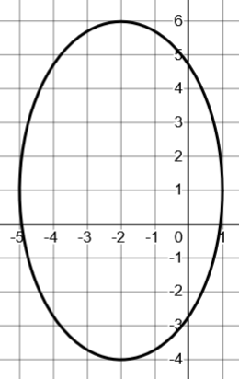
4). [P/C]
a). Give a set of parametric equations for this path (any movement is fine).
b). Give a different set of parametric equations for this path for which the point starts somewhere else at $t=0$ and moves in a different speed or direction around the ellipse.
c). Explain what parts of your equation from part b affect the shape of the path, which parts affect the motion, and why each part affects the aspect it does. (In other words, why does the part affecting the motion NOT affect the shape and vice versa).

5). [C] What’s the maximum and minimum x-value and y-value on the path defined by:
$$x\left(t\right)=5-\cos\left(t^{2}-1\right)$$
$$y\left(t\right)=2⋅sin\left(t^{2}-1\right)+4$$

6). Give a rough sketch of the path the movement defined by
$x\left(t\right)=3\cos\left(\frac{π}{2}-t\right)$ and $y\left(t\right)=\sin\left(\frac{π}{2}-t\right)+1$
Think about what each transformation does.
Think about largest and smallest possible x and y values. Think about where t = 0 is, and how the angle changes as time goes up.
Include t = 0 in your sketch and direction arrows.
(Make clear tick-marks showing scale for x and y)

7). Write your own equations for a circular motion centered at (-3, 5) with a circle radius 12. At t = 0 the point should be at (-15, 5) and move clockwise.

8). [C] Consider $x\left(t\right)=\cos\left(A\left(t\right)\right)$ and $y\left(t\right)=\sin\left(A\left(t\right)\right)$.
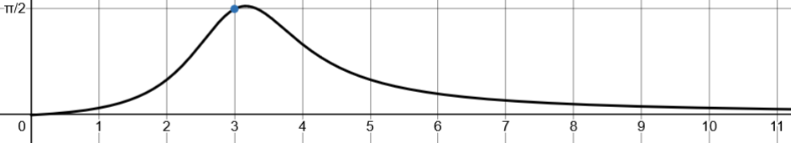
If $A(t)$ is given by this graph:
t
A(t)
a). What are the points (x, y) coordinates at $t=3$ ? (think about how the output of $A(t)$ is being used in the parametric equations).
b). Describe in words the movement of the point around the circle.

9). [P] Consider $x\left(t\right)=cos⁡(t)$ and $y\left(t\right)=sin⁡(t)$.
a). Modify the equations so that at t = 0 the point starts at the bottom of the circle and moves clockwise (at whatever speed you want).
b). Modify the equations so that at t= 0 the point is at an angle of $\frac{π}{4}$ and at t = 10 the point is at an angle of $\frac{3π}{4}$.

10). [C/P] Define a parameterization where a point moves in a circular motion but continually accelerates.

11). [C/P] In this problem you’ll figure out whether two different moving points ever collide.
Particle A moves as x = cos(t), y = sin(t). Particle B moves as x = cos(2t − π/3), y = sin(2t − π/3), both for t ≥ 0.
a). Do the two particles ever occupy the same point at the same time? If so, give the (x, y) coordinates of all the places where they collide. If not, give a convincing justification why they never do.
b). Re-write particle A’s equation: $x\left(t\right)=\cos\left(something\right)$ and $y\left(t\right)=\sin\left(something\right)$ so that the first time the two particles don’t collide before 100 seconds, but do collide sometime after 100 seconds.

c). Re-write particle A’s equation so that the first time the particles collide is at exactly 130 seconds.

Solutions for topic 2 – 7– Circular motion
1). [C]
a). Your partner doesn’t remember why $x\left(t\right)=cos(t)$ and $y\left(t\right)=sin(t)$ define a circular motion. Explain why this is true.
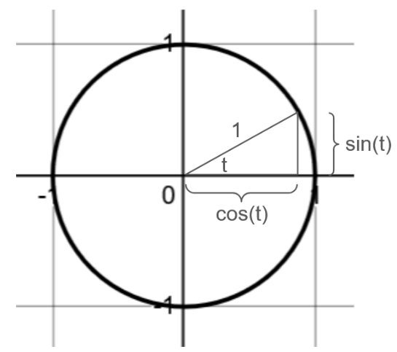
t is being used as the angle in $cos⁡(t)$ and $sin⁡(t)$. Remember that $\cos\left(θ\right)$ gives the x-coordinate of the point at an angle of theta. so, $cos(t)$ gives the x-coordinate of the point at an angle of t.
Sine gives the y-coordinate of a point at its input angle.
Using t for the angle means that as time increases, the angle increases, and cosine and sine convert that angle into (x, y) coordinates for the point at that angle.

b). Would $x\left(t\right)=sin⁡(t)$ and $y\left(t\right)=cos⁡(t)$ define a circular motion? Is it different from the pair of equations in part a? how?
Definitely. You could imagine this as the inverse because we’ve just swapped x and y.
reflect for the inverse
$$x\left(t\right)=sin(t)$$
$$y\left(t\right)=cos(t)$$

$$x\left(t\right)=cos(t)$$
$$y\left(t\right)=sin(t)$$

$$t=0$$
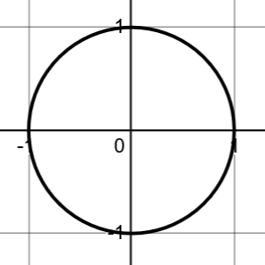

$$t=0$$

You can see the circular path is the same, but the movement starts at the top and moves clockwise.
Of course, you could get the same result by plotting points at $t=0,\frac{π}{4},\frac{π}{2},etc.$ but spotting the connection to inverses is more immediate and clear.

2). [P] Write the equation for circular motion around a circle radius 3, centered on (-4, 5).
Here we want to scale both x and y by a factor of 3, and then shift x left by 4 and shift y up by 5.
$x\left(t\right)=3⋅\sin\left(t\right)-4$ and $y\left(t\right)=3⋅\cos\left(t\right)+5$

3). [C] The purpose of this question is for you to think clearly about different ways the rotation can be reversed and why each makes sense.
a). Do $x\left(t\right)=cos⁡(t)$ and $y\left(t\right)=sin⁡(t)$ define clockwise or anti-clockwise movement?
It goes anti-clockwise because we always define an increasing angle as an anti-clockwise rotation from the positive horizontal axis.
b). For each of the following sets of equations, decide if they cause the movement to go the other direction from the basic equations in part a.

For each of these, you could make a table of values when $t=0,\frac{π}{4}, and\frac{π}{2}$ as an easy way to see what’s happening.
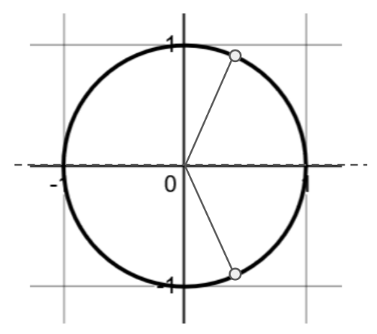
Conceptually, it’s nice to be able to think what’s going on without plugging anything in, so I’ll describe what I see in my mind below.

i. $x\left(t\right)=cos(t)$ $y\left(t\right)=-sin(t)$

I start by imagining the rotating point $x\left(t\right)=cos⁡(t)$ and $y\left(t\right)=sin⁡(t)$ and think: what will it look like if we reflect all the y-values? This creates clockwise movement.

ii. $x\left(t\right)=-cos\left(t\right)$ $y\left(t\right)=sin(t)$
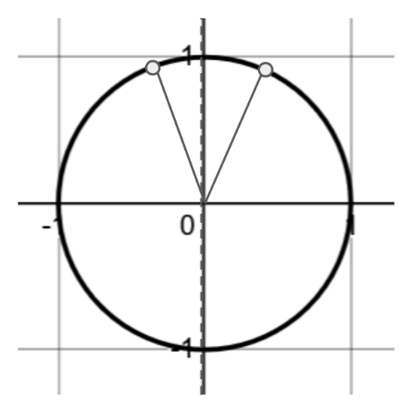
Here we can imagine the same original movement, but reflect all the x-values horizontally.

As you can see, this also creates a clockwise movement, except that at $t=0$ the point starts at (-1, 0).

iii. $x\left(t\right)=\sin\left(t\right)$ $y\left(t\right)=\cos\left(t\right)$

We already saw that this is like reflecting the original movement around the line y = x, and that creates a clockwise movement.

iv. $x\left(t\right)=\cos\left(-t\right)$ $y\left(t\right)=\sin\left(-t\right)$

This is literally describing rotating the opposite direction. We’re using $-t$ as the angle we grab the (x, y) coordinates for. So as t increases, we’re getting larger and larger negative angles, which is a clockwise rotation.

Of all these approaches, I’ll usually use the last one whenever I need clockwise rotation, since it feels conceptually cleanest. The others rely on reflecting x or y coordinates. Approach iv literally describes rotating in the opposite direction so it feels like the most direct way to do what I want.

4). [P/C]
a). Give a set of parametric equations for this path (any movement is fine).
Here the center is at $(-2, 1)$. We also need to figure out how much the circle was scaled vertically and horizontally. Before scaling, the vertical radius was 1. Now it’s 5 (the distance from the center at height 1 to the top at 6). The horizontal “radius” is 3. That gives us:
$x\left(t\right)=5⋅sin\left(t\right)+1$ and $y\left(t\right)=3⋅\cos\left(t\right)-2$
b). Give a different set of parametric equations for this path for which the point starts somewhere else at $t=0$ and moves in a different speed or direction around the ellipse.
Clearly lots of answers work here. Here’s now I think about mine.
Right now the angle we use to get (x, y) coordinates is just t. If $t=0$ we’re thinking of a point at an angle of 0. What if we use $\frac{π}{2}-t$ as our angle, like this: $x\left(t\right)=5⋅sin\left(\frac{π}{2}-t\right)+1$ and $y\left(t\right)=3⋅\cos\left(\frac{π}{2}-t\right)-2$
Now at $t=0$, the angle is straight up, so the point will start at the top of the ellipse. As t increases, $\frac{π}{2}-t$ will decrease, meaning the angle will decrease, so the point will rotate clockwise (the other direction from before).
You can use this idea to start the point at whatever angle you want, and control how the angle changes (increase or decrease, how fast it changes, etc.).
c). Explain what parts of your equation from part b affect the shape of the path, which parts affect the motion, and why each part affects the aspect it does. (In other words, why does the part affecting the motion NOT affect the shape and vice versa).
$x\left(t\right)=5⋅sin\left(\frac{π}{2}-t\right)+1$ and $y\left(t\right)=3⋅\cos\left(\frac{π}{2}-t\right)-2$
The shape of the path is everything outside the sine and cosine functions. It’s as if we’d said this:
$x\left(t\right)=5⋅\left(x-coordinate\right)+1$ $y=3\left(y-coordinate\right)-2$
That stretches and shifts the x and y coordinates to create the shape you want.
Everything inside the sine and cosine functions affect the movement, because that’s what determines how the angle changes with time, and the angle is what determines the x and y coordinates that then get stretched and shifted. So: $\frac{π}{2}-t$ is the part that controls the movement.

5). [C] What’s the maximum and minimum x-value and y-value on the path defined by:
$$x\left(t\right)=5-\cos\left(t^{2}-1\right)$$
$$y\left(t\right)=2⋅sin\left(t^{2}-1\right)+4$$
If we want to know the largest and smallest x value, the $t^{2}-1$ part isn’t relevant, because that’s going to be about an angle, not an x-coordinate. The output of cosine determines the x coordinate, and the output of cosine is always between -1 and 1.
Here’s what I see: $x\left(t\right)=5-\cos\left(t^{2}-1\right)$
I think: cosine is between -1 and 1. So $x(t)$ is between $5-(-1)$ and $5-(1)$. In other words, between 4 and 6.
Similarly with sine. $y\left(t\right)=2⋅sin\left(t^{2}-1\right)+4$
If sine outputs 1, then $y=2+4=6$. If sine outputs -1, then $y=2⋅\left(-1\right)+4=2$
So the y-values are between 2 and 6.

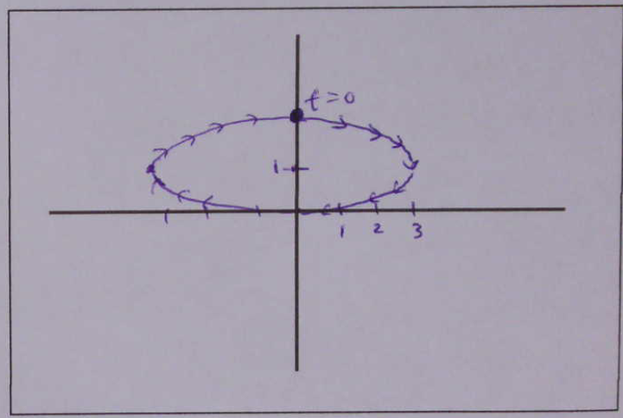
6). [P] Give a rough sketch of the path the movement defined by
$x\left(t\right)=3cos⁡(\frac{π}{2}-t)$ and $y\left(t\right)=\sin\left(\frac{π}{2}-t\right)+1$ .
For the path, I see that it’s a transformed circle. It’s been horizontally stretched by 3, and vertically shifted up by 1.
The movement starts at an angle of $\frac{π}{2}$ and the angle decreases, creating a clockwise movement.

7). [P] Write your own equations for a circular motion centered at (-3, 5) with a circle radius 12. At t = 0 the point should be at (-15, 5) and move clockwise.
$$x\left(t\right)=12\cos\left(π-t\right)-3$$
$$y\left(t\right)=12\sin\left(π-t\right)+5$$

8). [C] Consider $x\left(t\right)=\cos\left(A\left(t\right)\right)$ and $y\left(t\right)=\sin\left(A\left(t\right)\right)$.

If $A(t)$ is given by this graph:
t
A(t)
a). What are the points (x, y) coordinates at $t=3$ ? (think about how the output of $A(t)$ is being used in the parametric equations).
At $t=3$ is see that $A\left(3\right)=\frac{π}{2}$.
That means $x\left(3\right)=\cos\left(A\left(3\right)\right)=\cos\left(\frac{π}{2}\right)=0$ and $y\left(3\right)=\sin\left(A(3)\right)=\sin\left(\frac{π}{2}\right)=1$
So the point is at (0, 1). In other words, at the (x, y) coordinates corresponding to the angle $\frac{π}{2}$.
b). Describe in words the movement of the point around the circle.
The point looks like it starts at an angle of 0 (the right side of the circle) and moves anti-clockwise until t = 3 when it’s made a quarter-turn. It rotates slightly beyond that, and then turns around and rotates clockwise towards 0 (right side of the circle) but never gets there as it decreases its rotational speed.
9). [P] Consider $x\left(t\right)=cos⁡(t)$ and $y\left(t\right)=sin⁡(t)$.
a). Modify the equations so that at t = 0 the point starts at the bottom of the circle and moves clockwise (at whatever speed you want).
$x\left(t\right)=cos\left(\frac{3π}{2}-t\right)$ and $y\left(t\right)=sin\left(\frac{3π}{2}-t\right)$ would work.
How can we know? Imagine $A\left(t\right)=\frac{3π}{2}-t$ gives the angle as a function of time. What’s the angle at t = 0? As t increases, what’s the angle doing? Is that moving clockwise or anti-clockwise?
We can use that $A(t)$ expression in the place that describes angle – inside the sine and cosine.

b). Modify the equations so that at t= 0 the point is at an angle of $\frac{π}{4}$ and at t = 10 the point is at an angle of $\frac{3π}{4}$.
$x\left(t\right)=cos\left(\frac{π}{4}+\frac{π}{20}t\right)$ and $y\left(t\right)=sin\left(\frac{π}{4}+\frac{π}{20}t\right)$

10). [C/P] Define a parameterization where a point moves in a circular motion but continually accelerates.
Remember, a circular path is defined with $x\left(t\right)=cos⁡( A(t) )$ and $y\left(t\right)=sin⁡( A\left(t\right) )$ while the specific movement can be controlled with an expression inside for the angle as a function of time.
If $A\left(t\right)=t^{2}$, for example, or $A\left(t\right)=2^{t}$ you have curves where the angle changes at a rate that continually increases. So:
$x\left(t\right)=cos⁡(2^{t})$ and $y\left(t\right)=\sin\left(2^{t}\right)$ would work as a solution.

11). [C/P] In this problem you’ll figure out whether two different moving points ever collide.
Particle A moves as x = cos(t), y = sin(t). Particle B moves as x = cos(2t − π/3), y = sin(2t − π/3), both for t ≥ 0.
a). Do the two particles ever occupy the same point at the same time? If so, give the (x, y) coordinates of all the places where they collide. If not, give a convincing justification why they never do.
The path of both particles is the same: it’s a radius 1 circle centered at the origin.
So the only way they’d be in the same place at the same time is if the angle is the same at the same time.
This would happen if $t=2t-\frac{π}{3}$. Solving for t: $t=\frac{π}{3}$ .
We can use that time to find the (x, y) coordinates: $x\left(\frac{π}{3}\right)=\cos\left(\frac{π}{3}\right)=\frac{1}{2}$ and $y\left(\frac{π}{3}\right)=\sin\left(\frac{π}{3}\right)=\frac{\sqrt{3}}{2}$
So they collide at the location $\left(\frac{1}{2},\frac{\sqrt{3}}{2}\right)$

b). Re-write particle A’s equation: $x\left(t\right)=\cos\left(something\right)$ and $y\left(t\right)=\sin\left(something\right)$ so that the first time the two particles don’t collide before 100 seconds, but do collide sometime after 100 seconds.
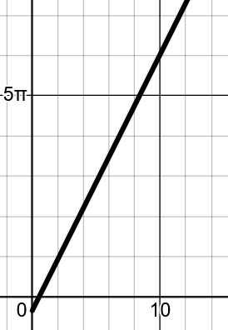
t
Angle
Particle B’s Angle
The angle of particle B is given by $2t-\frac{π}{3}$. Here’s a picture of the graph of angle as a function of time.

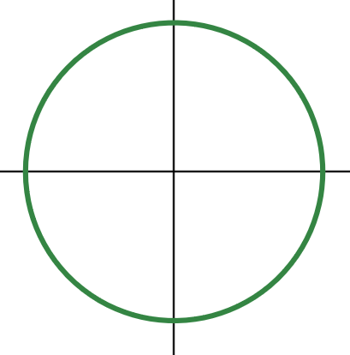
If the angle of particle A is ever a multiple of $2π$ away from the angle of B, they will be in the same location (think about this!). So the first time this happens must be when $t>100$.
B
A
Particle A travels slightly slower

A straightforward way to do this is to make sure that the angle for particle A is always close to B, and the first time the angles are the same is when $t>100$.

If you think about it as a race, particle A can start out a bit ahead of particle B but go slightly slower. Particle B will very slowly catch up, but it will take more than 100 seconds to do so. In my picture I’ll have A start at an angle of 0, but rotate slower.

Something like $x\left(t\right)=\cos\left(1.99t\right)$ and $y\left(t\right)=\sin\left(1.99t\right)$ because 1.99 is a little slower than 2.
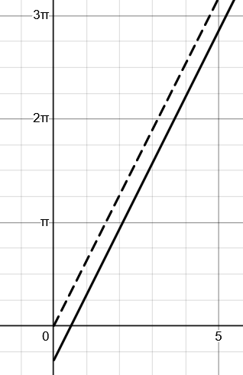
Is that slow enough? Let’s see when $2t-\frac{π}{3}$ and $1.99t$ are equal to check.
Particle B’s angle. Slope is slightly less than A’s
Particle A’s angle.

$2t-\frac{π}{3}=1.99t$ $0.01t=\frac{π}{3}$

$\frac{1}{100}t=\frac{π}{3}$ $t=\frac{100⋅π}{3}≈104.6$

So that seems to have worked!
So $x\left(t\right)=\cos\left(1.99t\right)$ and $y\left(t\right)=\sin\left(1.99t\right)$ is one solution.

You can also imagine this in terms of the graphs of the two angle functions. Have one angle start a little bit different than the other with a slightly smaller slope. You know that eventually they’ll cross and you can control when they cross by adjusting the slope of the second one.

c). Re-write particle A’s equation so that the first time the particles collide is at exactly 130 seconds.

Let’s set up the same equation but solve for the time we want them to intersect. Let’s say particle A’s angle is given by $s⋅t$ where s (for slope) is some number. I want to solve for the number that will cause them to intersect when $t=130$.
$2\left(130\right)-\frac{π}{3}=s⋅130$ $260-\frac{π}{3}=130⋅s$ $s=2-\frac{π}{390}$
So: $x\left(t\right)=\cos\left(t⋅\left(2-\frac{π}{390}\right)\right)$ and $y\left(t\right)=\sin\left(t⋅\left(2-\frac{π}{390}\right)\right)$.

